**15-2_SQL_Trushkova_DML_views**

A pseudocolumn which assigns a sequential value starting with 1 to each of the rows returned from the subquery- ROWNUM

Specifies that INSERTS and UPDATES performed through the view can’t create rows which the view cannot select- WITH CHECK OPTION

Ensures that no DML operations can be performed on this view- WITH READ ONLY

**Try it/Solve it**

1. Query the data dictionary USER_UPDATABLE_COLUMNS to make sure the columns in the base tables will allow UPDATE, INSERT, or DELETE. Use a SELECT statement or the Browse Data Dictionary feature in HTML DB. All table names in the data dictionary are stored in uppercase.

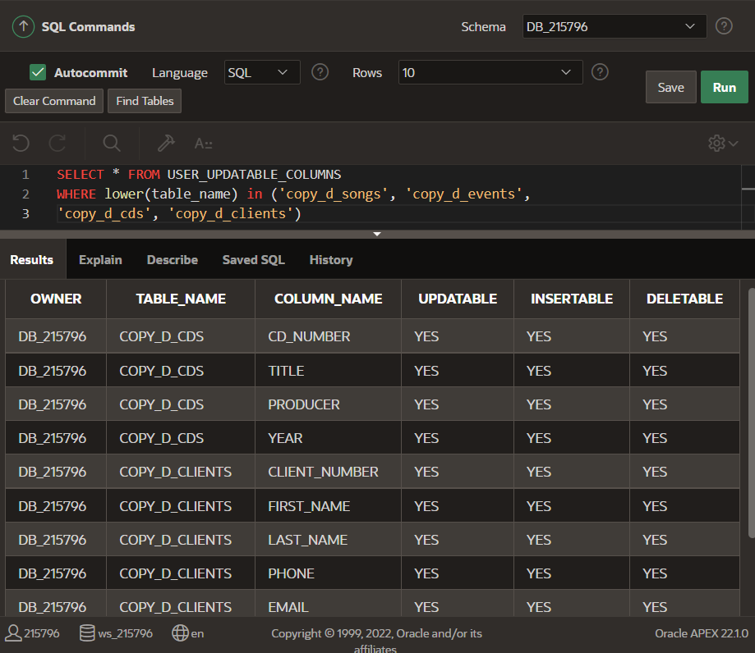

1. Use the CREATE or REPLACE option to create a view of all the columns in the copy_d_songs table called view_copy_d_songs.

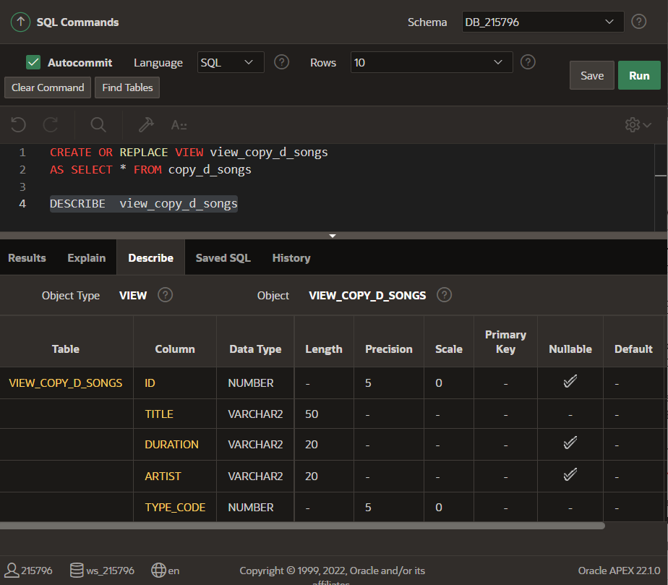

1. Use view_copy_d_songs to INSERT the following data into the underlying copy_d_songs table. Execute a SELECT * from copy_d_songs to verify your DML command. See the graphic.

|  |  |  |  |  |
| --- | --- | --- | --- | --- |
| ID | TITLE | DURATION | ARTIST | TYPE_CODE |
| 88 | Mello Jello | 2 | The What | 4 |

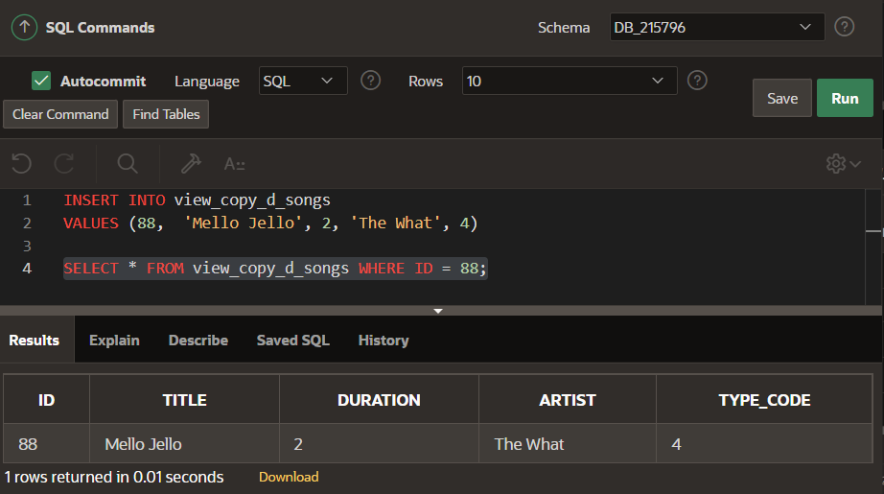

1. Create a view based on the DJs on Demand COPY_D_CDS table. Name the view read_copy_d_cds. Select all columns to be included in the view. Add a WHERE clause to restrict the year to 2000. Add the WITH READ ONLY option.

1. Using the read_copy_d_cds view, execute a DELETE FROM read_copy_d_cds WHERE cd_number = 90;

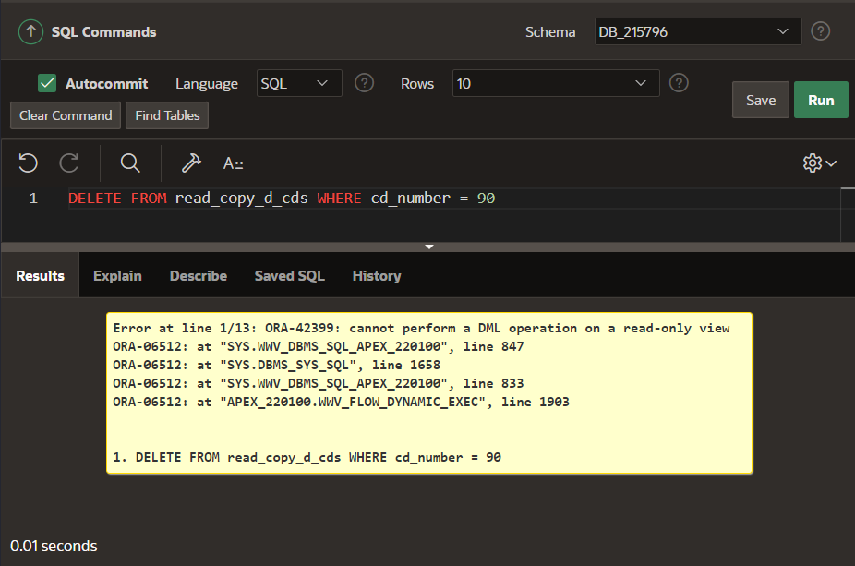

1. Use REPLACE to modify read_copy_d_cds. Replace the READ ONLY option with WITH CHECK OPTION CONSTRAINT ck_read_copy_d_cds. Execute a SELECT * statement to verify that the view exists.

1. Use the read_copy_d_cds view to delete any CD of year 2000 from the underlying copy_d_cds.

1. Use the read_copy_d_cds view to delete cd_number 90 from the underlying copy_d_cds table.

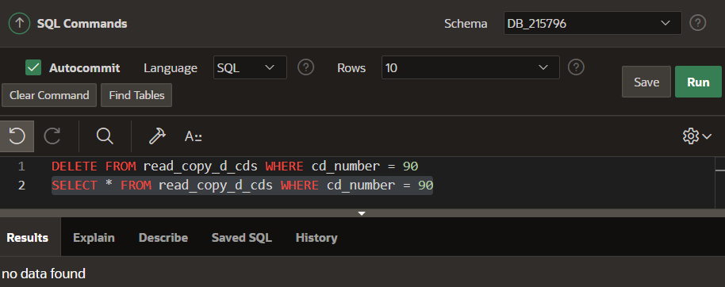

1. Use the read_copy_d_cds view to delete year 2001 records.

1. Execute a SELECT * statement for the base table copy_d_cds. What rows were deleted?

1. What are the restrictions on modifying data through a view?

For simple views, all DML’s are OK, but for complex views:

**Delete restricted if it contains:**

Group functions

GROUP BY CLAUSE

DISTINCT

pseudocolumn ROWNUM  Keyword

**Modify restricted if it contains:**

Group functions

GROUP BY CLAUSE

DISTINCT

ROWNUM Keyword

**INSERT restricted if it contains:**

Group functions

GROUP BY CLAUSE

DISTINCT

ROWNUM

Column defined by expressions